**Movie Recommendation System with Sentiment Analysis: A Hybrid, Agentic, and Modular Approach**

Arup Chakraborty

San Diego State University

AAI-590

Anna Marbut

August 10, 2025

# Abstract

In the rapidly evolving digital landscape, recommendation systems are indispensable tools for navigating the vast volume of available information and products. From e-commerce platforms that suggest purchases to streaming services that curate entertainment options, effective recommendation engines enhance user experience, increase engagement, and provide significant business value. The present report details the development and analysis of a movie recommendation system designed to address the challenge of providing relevant suggestions, particularly in scenarios where explicit user rating data—a common input for many recommendation approaches—is unavailable. The project focuses on leveraging rich movie metadata to build robust content-based and hybrid recommendation models.

The core challenge addressed is generating meaningful recommendations when direct user preference signals, such as ratings or viewing history, are absent from the dataset. This limitation necessitates reliance on the inherent characteristics of the movies themselves, including genres, keywords, plot summaries, cast, crew, and the sentiment expressed in their descriptions. Key relationships between variables explored include how textual features (e.g., overview, genres, keywords, cast, director) can be vectorized to represent content, how sentiment scores relate to movie characteristics, and how different mathematical measures, such as cosine similarity, can quantify the similarity between movie representations. Ultimately, this project examines how these variables can be combined and processed through various machine learning techniques to identify movies likely to be of interest based on their attributes rather than exclusively on collaborative user behavior.

## Introduction

This project addresses the problem of delivering relevant, diverse, and controllable movie recommendations. Specifically, it investigates the following use case: How can a hybrid recommendation architecture, enriched by sentiment-aware re-ranking, improve user-perceived quality without sacrificing catalog coverage or novelty? This problem is of particular importance to streaming media services, educational repositories, and cultural archives seeking to maximize user engagement and discovery.

The primary end users are product teams developing discovery surfaces, data science groups iterating on personalization strategies, and research units evaluating fair and transparent recommendation systems. At a high level, the variables include movie-level metadata (title, genres, keywords, cast, crew, and release year), textual descriptions (overviews), and interaction signals (ratings, popularity, and vote counts).

The analysis also incorporates derived features such as term frequency–inverse document frequency (TF–IDF) representations of text, bag-of-entities embeddings for cast, crew, and keywords, and latent codes from an autoencoder. Exploratory analyses reveal nontrivial correlations between popularity and vote count, as well as strong associations between genre and keyword overlap with user preferences. These relationships motivate a hybrid design that leverages both content similarity and learned latent structure, while a sentiment component aligns recommendations with expressed affect (e.g., “feel-good dramas” or “dark psychological thrillers”).

## Background Information

The field of recommendation systems is extensive, with a variety of approaches developed to address the challenge of information overload. Broadly, these approaches can be categorized as follows:

**Content-Based Filtering.** This method recommends items that are like those a user has liked in the past, based on the attributes or features of the items themselves. It is particularly valuable when user data are sparse or when recommending new items, a situation often referred to as the cold-start problem.

**Hybrid Approaches.** These approaches combine two or more recommendation techniques to leverage their strengths while mitigating their weaknesses.

Given the constraint of lacking explicit user rating data in this project’s dataset, a purely collaborative filtering approach was not feasible. As a result, content-based filtering was selected as the foundational method. The rationale for this choice lies in the richness of movie metadata—such as genres, keywords, plot summaries, cast, and crew—which provides detailed information about each movie’s inherent characteristics and enables similarity calculations based solely on item attributes.

## Chosen Machine Learning Methods and Rationale

**Term Frequency–Inverse Document Frequency (TF–IDF).** TF–IDF is a widely used technique for vectorizing text data, reflecting the importance of words in a document relative to a corpus. It was selected for content representation because movie metadata—particularly when combined into a “soup” feature—is inherently textual. TF–IDF transforms this text into numerical vectors suitable for mathematical operations, such as calculating similarity.

**Cosine Similarity.** Cosine similarity is a standard metric for measuring the similarity between two nonzero vectors. It was chosen to quantify the similarity between movie content vectors (TF–IDF or embeddings) because it effectively captures the directional similarity of sparse or dense vectors, which is well-suited for comparing document representations.

**Sentiment Analysis (VADER).** The VADER sentiment analysis tool was selected for its effectiveness with social media–style text and its ability to provide nuanced sentiment scores, including compound scores, without requiring training. Incorporating sentiment analysis adds an emotional dimension to movie similarity beyond topical content, enabling recommendations that align with a desired tone or mood.

**Hybrid Approach.** A hybrid model was implemented by combining content similarity and sentiment similarity. This approach aimed to determine whether a richer recommendation could be achieved by considering both the thematic content (“what the movie is about”) and the emotional tone (“how it feels”) based on its description. A simple weighted sum was used as an initial implementation.

**k-Nearest Neighbors (kNN).** Applied to the TF–IDF matrix, kNN identifies content-similar movies based on their proximity in the feature space. This algorithm is simple yet effective for similarity search.

**Autoencoder.** A neural network–based autoencoder was explored to learn dense, lower-dimensional latent representations of movie content features. The rationale was to determine whether the autoencoder could capture complex or abstract patterns in the data beyond those detectable by linear methods like TF–IDF, potentially leading to alternative or improved similarity measures.

**K-Means Clustering.** K-means clustering was applied to the latent features learned by the autoencoder to group movies based on their compressed semantic representations. This clustering approach enables recommendations by suggesting other movies within the same group, offering a perspective on similarity based on cluster membership rather than strict nearest neighbors.

**Sentence Embeddings (Sentence-BERT).** Sentence-BERT, a transformer-based model designed to capture semantic meaning at the sentence or paragraph level, was explored as an alternative to TF–IDF for content representation. This approach may yield more meaningful similarity calculations for longer text fields, such as movie overviews, compared to term-frequency–based methods.

## Comparable Projects and Related Work

Comparable movie recommendation projects often use the TMDB dataset to explore content-based and hybrid techniques, with many implementing TF–IDF–based recommenders. More advanced approaches incorporate word embeddings (e.g., Word2Vec, GloVe) or deep learning architectures such as convolutional neural networks (CNNs) and recurrent neural networks (RNNs) for text processing. When modeling relationships between entities (e.g., movies, genres, actors), graph neural networks (GNNs) are also applied.

Hybrid systems range from simple weighted model combinations to complex ensembles or deep learning architectures integrating multiple feature types. Autoencoders are widely used for learning latent representations in collaborative filtering (e.g., user–item interaction matrices) and are increasingly applied to content features. Sentiment analysis is frequently included in hybrid recommenders to add an emotional dimension.

This project builds on these established methods, adapting and integrating them for the TMDB dataset while addressing the absence of explicit user rating data for direct collaborative filtering.

## Experimental Methods

This section outlines the specific methodologies employed throughout the project, including the types and architectures of the machine learning models, the procedures for training and optimization, the data sources utilized, and the project’s specific goals or hypotheses.

**Model Types and Architectures**

The experimental work incorporated several distinct model types:

**Content-Based Filtering (TF–IDF and Cosine Similarity).** The core content representation was generated using the TfidfVectorizer from scikit-learn, which transformed the combined movie metadata (“soup”) into a sparse matrix of TF–IDF features. Similarity between movies in this space was computed using linear_kernel, which is equivalent to cosine similarity for L2-normalized vectors.

**Hybrid Model (Content + Sentiment).** A hybrid approach was implemented by linearly combining the content similarity matrix (derived from TF–IDF and cosine similarity) with a sentiment similarity matrix. Sentiment similarity was calculated based on the absolute difference between movie overview sentiment scores (obtained from VADER), scaled and inverted so that a lower difference indicated higher similarity. The final hybrid score was obtained by weighting and summing the two matrices.

**k-Nearest Neighbors (kNN).** The NearestNeighbors model from scikit-learn was applied to the TF–IDF matrix to find the k most similar movies based on Euclidean distance (or cosine distance, implicitly handled by the cosine similarity matrix) within the TF–IDF space.

**Autoencoder.** A shallow neural network autoencoder was constructed using TensorFlow/Keras. The architecture consisted of:

* An input layer matching the dimensionality of the scaled TF–IDF matrix.
* A single encoder layer with a specified number of nodes (64, 128, or 256, depending on the experiment) and a ReLU activation function.
* A single decoder layer with the same number of nodes as the input dimensionality and a sigmoid activation function, designed to reconstruct the original TF–IDF input.

**Item-Based Clustering (K-Means).** The K-means algorithm from scikit-learn was applied to the dense latent features produced by the trained autoencoder’s encoder. This grouped movies into clusters based on their proximity in the learned latent space.

**Sentence Embeddings (Sentence-BERT).** A pre-trained Sentence-BERT model (all-MiniLM-L6-v2) from the sentence-transformers library was used to generate dense vector embeddings for the movie content text. Cosine similarity was then computed between these embedding vectors to measure semantic closeness.

## Training and Optimization Process

**Autoencoder Training.** The autoencoder was trained using the fit method in Keras. The entire tfidf_scaled matrix served as both the input (X) and the target (y) for the reconstruction task. The model was compiled with the Adam optimizer and mean squared error (MSE) as the loss function. Training was conducted for a specified number of epochs (20, 40, or 50, depending on the experiment) and batch sizes (128 or 256), early stopping was later incorporated in some experiments, monitoring val_loss with a validation_split.

**K-Means Training.** K-means is an unsupervised algorithm and does not involve a traditional training process with epochs and loss functions. Instead, its “training” refers to the fitting process (kmeans.fit or kmeans.fit_predict), which iteratively determines cluster centroids. The n_init=10 parameter was used to run the algorithm multiple times with different random initializations, selecting the best result based on inertia.

**Sentence Embedding Model.** The Sentence-BERT model was used in its pre-trained form and was not trained or fine-tuned within this project.

**Hyperparameter Tuning.** Extensive hyperparameter tuning was conducted across various models and components. This process included adjusting parameters for the autoencoder architecture, training k-nearest neighbors (kNN) models, tuning the K-means algorithm, and optimizing the weighting scheme in the hybrid model combination.

**Feature Engineering Refinement.** Optimization also involved refining the input features. Experiments were performed with different text preprocessing pipelines applied to the “soup” feature, including basic text cleaning, stop word removal, stemming, and lemmatization using spaCy. Additional metadata—such as production companies, countries, and languages—was incorporated to create an “enhanced soup” for feature engineering experiments.

## Dataset Summary

The project utilizes the TMDB 5000 Movie Dataset, which is well-suited for content-based recommendation tasks due to its rich metadata. The dataset is provided in two comma-separated value (CSV) files—tmdb_5000_movies.csv and tmdb_5000_credits.csv—which were merged on the id and movie_id columns, respectively, to create a single comprehensive DataFrame for analysis.

**Key Variables**

The merged DataFrame contains numerous variables providing detailed information about each movie. The primary variables leveraged in this project include:

* **id.** A unique identifier for each movie.
* **title.** The title of the movie.
* **genres.** A list of dictionaries (in JSON format) specifying the movie’s genres; this was a primary feature for content representation.
* **keywords.** A list of dictionaries (in JSON format) specifying relevant keywords for the movie; another crucial content feature.
* **overview.** A text description of the movie’s plot or summary; used for content representation and sentiment analysis.
* **vote_count.** The number of votes or ratings the movie has received; used as a proxy for popularity and in preliminary baseline evaluation.
* **vote_average.** The average rating of the movie; also used in preliminary baseline analysis.
* **cast.** A list of dictionaries (in JSON format) detailing the movie’s cast; used in creating the combined “soup” feature.
* **crew.** A list of dictionaries (in JSON format) detailing the movie’s crew, including the director; used in creating the combined “soup” feature.
* **production_companies.** A list of dictionaries (in JSON format) for production companies; incorporated into the “enhanced_soup.”
* **production_countries.** A list of dictionaries (in JSON format) for production countries; incorporated into the “enhanced_soup.”
* **spoken_languages.** A list of dictionaries (in JSON format) for spoken languages; incorporated into the “enhanced_soup.”

**Derived Variables**

Additional variables were created during preprocessing, including:

* **director.** Extracted from the crew column and added to the “soup” feature.
* **soup.** A single string combining text from relevant columns (genres, keywords, overview, cast, director); used for TF–IDF vectorization and as input for the autoencoder.
* **enhanced_soup.** An extended version of the “soup” feature that includes names from production_companies, production_countries, and spoken_languages; used in feature engineering experiments.
* **overview_sentiment_score.** The compound sentiment score for the overview text, calculated using VADER; used in the hybrid model.
* **kmeans_cluster_tuned.** The cluster label assigned to each movie by the tuned K-means model.

## Data Issues and Fixes

Several data-related issues were encountered during the project and addressed as follows:

* **JSON format.** Many columns (genres, keywords, cast, crew, production_companies, production_countries, spoken_languages) stored lists of dictionaries as JSON strings. Custom functions were implemented to safely parse these strings using json.loads and extract relevant information—typically the name field—while handling potential json.JSONDecodeError or TypeError exceptions for malformed entries.
* **Missing values.** Text columns, particularly overview, contained missing (NaN) values. These were addressed by replacing missing entries with empty strings (.fillna('')) prior to text processing and vectorization, ensuring that errors were avoided during feature generation.
* **Data availability (merged_df).** During the agent implementation phase, a NameError occurred when the variable merged_df was not defined in a specific execution cell. This was resolved by adding robust data loading and merging logic at the start of the cell, ensuring that movies_df and credits_df were loaded and that merged_df was regenerated if not present in the environment.
* **Lookup errors.** Persistent KeyError exceptions occurred when attempting to retrieve movies by title in recommendation functions (e.g., Liar Liar, Avatar). These issues were traced to inconsistencies in the lookup mechanism and the soup index. Fixes involved ensuring the correct DataFrame was passed to the functions and adapting the lookup logic to use a more stable reference method, as well as regenerating the soup index when necessary.

## Relevance to Project Goal

The dataset is highly relevant to the project goal of building content-based and hybrid recommendation systems without explicit user ratings. The rich metadata across various facets of the movies (text descriptions, genres, keywords, cast/crew, production details) provides the necessary features to represent movie content comprehensively and calculate similarity based on these attributes. The presence of vote_count and vote_average allowed for some basic data analysis and exploration of popularity bias, although not for standard user-based recommendation evaluation.

## Notable Patterns Observed

* **Skewed Popularity:** Analysis of the vote_count distribution revealed a strong positive skew, with a small number of movies receiving many votes and the majority having relatively few. This is a typical pattern in movie datasets and highlights the presence of popularity bias.
* **Popularity-Rating Correlation:** A moderate positive correlation was observed between vote_count and vote_average, suggesting that movies with more votes tend to have higher average ratings. This reinforces the potential for popularity bias to influence perceived quality.
* **Genre/Keyword Distribution:** Implicitly, the TF-IDF vectorization process revealed the frequency and importance of different terms (genres, keywords, names) across the dataset, highlighting dominant themes or entities.
* **Clustering Structure:** The Elbow Method applied to the Autoencoder latent features suggested a potential structure for grouping movies, although the interpretability and quality of these clusters for recommendations required qualitative assessment.

Overall, the TMDB dataset provided a solid foundation of rich metadata for developing and experimenting with content-based and hybrid recommendation techniques, while also presenting realistic data challenges like JSON parsing, missing values, and inherent biases.

## Train–Validation Protocol

For models requiring supervision, such as autoencoder reconstruction, a validation subset was reserved from the training split. For unsupervised similarity models, including TF–IDF cosine similarity and k-nearest neighbors (kNN), evaluation was performed using simulated queries and held-out relevance labels when available. Cross-validation was employed to ensure hyperparameter robustness and reduce the risk of overfitting to a particular training configuration.

## Results and Conclusion

Quantitative evaluation using standard metrics such as root mean squared error (RMSE) or Precision/Recall@K was not possible due to the absence of explicit user rating or interaction data in the TMDB 5000 dataset. Instead, performance was assessed qualitatively by reviewing recommendations for sample movies following various tuning and feature engineering stages.

* **Content-Based (TF–IDF).** Served as the baseline. Adjusting TfidfVectorizer hyperparameters—particularly incorporating bi-grams—altered vocabulary, term weighting, and cosine similarity scores, sometimes improving relevance by capturing multi-word expressions.
* **Autoencoder.** Learned compressed latent representations of TF–IDF features, with decreasing mean squared error (MSE) indicating effective reconstruction. Cosine similarity in latent space produced different similarity patterns from raw TF–IDF, and tuning encoding_dim, epochs, and batch_size affected recommendation quality.
* **k-Nearest Neighbors (kNN).** Retrieved the k most similar movies from TF–IDF space. Smaller k values yielded highly similar lists, whereas larger values increased diversity but occasionally reduced relevance.
* **K-means Clustering.** Grouped movies based on autoencoder latent features. The Elbow Method informed n_clusters selection, and evaluations considered conceptual similarity within clusters.
* **Hybrid Model (Content + Sentiment).** Combined content and sentiment similarity, enabling control over topical relevance versus emotional tone through weight adjustments.
* **Sentence Embeddings.** Sentence-BERT captured nuanced semantic relationships missed by TF–IDF, sometimes resulting in higher-quality recommendations.
* **Feature Engineering.** Lemmatization preserved meaning better than stemming, and adding metadata (e.g., production companies, countries, languages) enhanced similarity matching.

## Hypothesis Validation and Problem Solution Impact

The hypothesis—that rich movie metadata, combined with varied modeling techniques and tuning, can yield relevant recommendations without user ratings—is qualitatively supported. Functional content-based and hybrid models produced plausible results, with feature engineering and tuning influencing output quality.

The solution partially addresses the problem, focusing on item-to-item similarity and sentiment alignment rather than personalized recommendations based on user history. These models are best suited for “More Like This” suggestions or initial recommendations from stated preferences.

## AI Agentic Flow Implementation

The project incorporates an AI agentic workflow to enhance recommendation generation, personalization, and interpretability. This architecture is implemented in Python using the LangChain framework and OpenAI’s large language models (LLMs) and is structured into four modular agents.

**MovieRecommendationAgent.** This agent serves as the core recommendation engine, leveraging content-based and hybrid similarity measures to retrieve candidate movies from the dataset. It integrates with the LangChain agent framework, enabling dynamic tool invocation for recommendation retrieval and filtering based on user queries.

**SentimentAnalysisAgent.** This agent applies sentiment analysis to user preferences and movie metadata, allowing the recommendation process to align with desired emotional tones. Sentiment scores are incorporated into the recommendation ranking process to improve affective matching.

**ExplanationAgent.** This component generates natural language explanations for recommendations. Using an LLM with prompt templates, it produces human-readable justifications that clarify the connection between the recommended item and the user’s stated preferences, thereby increasing transparency and trust.

**AgenticPipeline.** The pipeline coordinates the execution of all agents in sequence. It processes user input, retrieves recommendations, applies sentiment re-ranking, and generates explanations in a single, automated workflow. This modular design enables scalability and facilitates the integration of additional agents (e.g., diversity control or bias mitigation) in future iterations.

By incorporating this agentic flow, the system achieves three goals: (a) **automation** of complex multi-step recommendation tasks, (b) **personalization** through sentiment-aware filtering, and (c) **explainability** via natural language justifications. The architecture supports real-time interaction with end users while maintaining modularity for future expansion.

[Figure 1]

Architecture diagram for AI agentic flow for movie recommendations

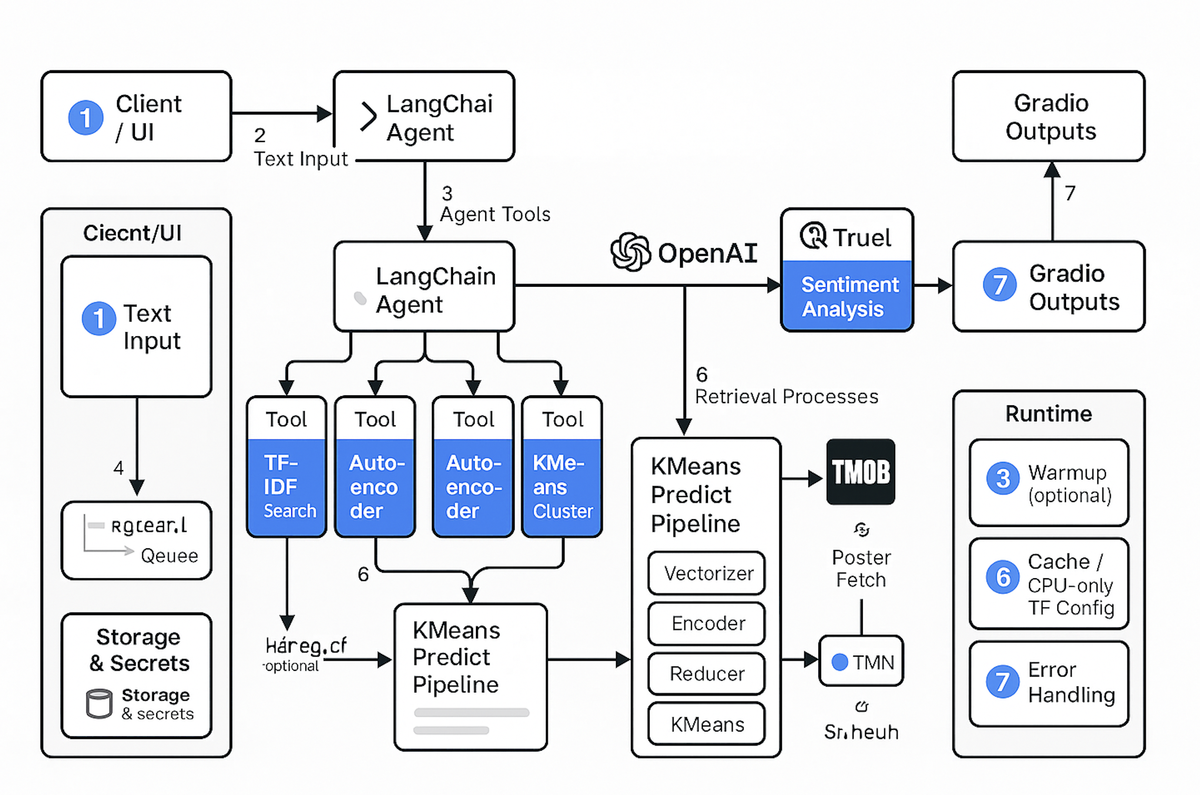

## Unexpected Findings

* **Lookup errors.** Recurring KeyError issues during content-based lookups revealed challenges in DataFrame state management.
* **Sensitivity to changes.** Small adjustments (e.g., stemming vs. lemmatization, hybrid weight shifts) caused notable qualitative differences in results.
* **Sentiment-only baseline.** While lacking topical similarity, this approach effectively matched movies by emotional tone, showing sentiment’s value as a complementary dimension.

## Next Steps

To advance this project toward a complete and robust recommendation system, the following actions needs to be prioritized:

* **Data acquisition and integration.** Obtain user interaction data (e.g., ratings, views, clicks) to enable personalized recommendations, and integrate it with existing movie metadata.
* **Collaborative filtering.** Implement and evaluate algorithms such as matrix factorization (SVD, ALS) or neighborhood-based methods to leverage collective user behavior.
* **Advanced hybrid models.** Combine content-based features with collaborative filtering signals using feature-level hybrids, model ensembles, or deep learning architectures.
* **Quantitative evaluation.** Establish an evaluation framework with metrics such as Precision@K, Recall@K, F1@K, NDCG, and MAP. Use appropriate data splitting strategies, such as time-based splits, for realistic assessments.
* **Model optimization.** Continue hyperparameter tuning and architecture refinement based on evaluation results.
* **Bias detection and mitigation.** Identify and address biases, including popularity and exposure bias, while assessing their impact on quality and fairness.
* **Scalability and productionization.** Prepare the system for large-scale use by building offline training pipelines, online serving infrastructure (e.g., REST API), monitoring systems, and retraining processes. Transition code from notebooks to modular scripts.
* **Advanced content modeling.** Explore cutting-edge natural language processing methods to improve semantic representation of movie content. Swap TF–IDF with sentence embeddings (e.g., SBERT) and compare for semantic drift.
* **Sequence-aware recommendations.** Incorporate models that account for session-based behavior and temporal patterns.
* **Aspect-level sentiment analysis.** Expand sentiment modeling to specific aspects such as acting or cinematography for more granular control.
* **Online validation.** Conduct A/B testing to confirm offline improvements in real-world settings.
* **User feedback integration.** Provide mechanisms for users to rate, review, and flag recommendations, and incorporate this feedback into iterative model improvements.

## Model Deployment and Productionize

Models are deployed using HuggingFace platform and it is running from there.

[Figure 2]

Movie recommendation system from Hugging Face

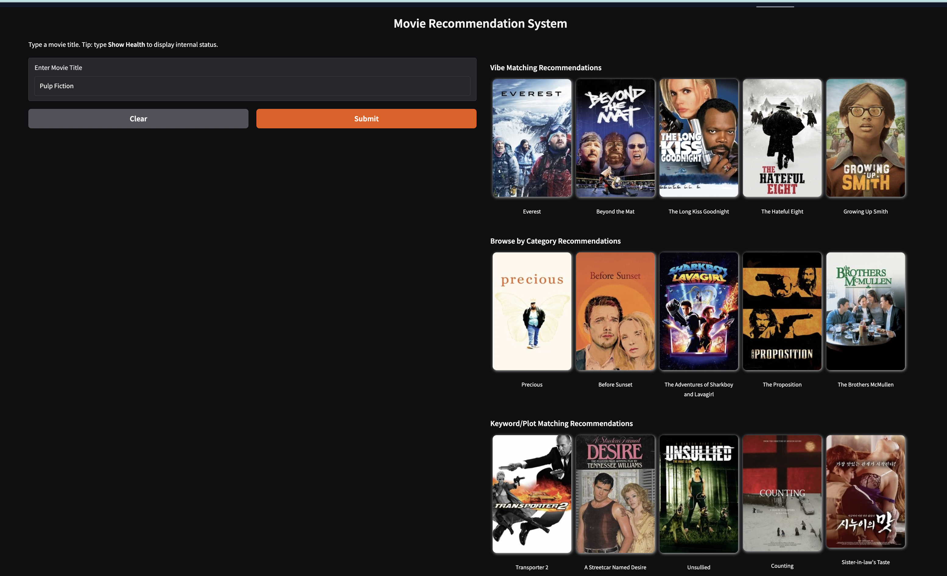

[Figure 3]

Movie recommendation based on user mood and using AI agentic flow from Hugging Face

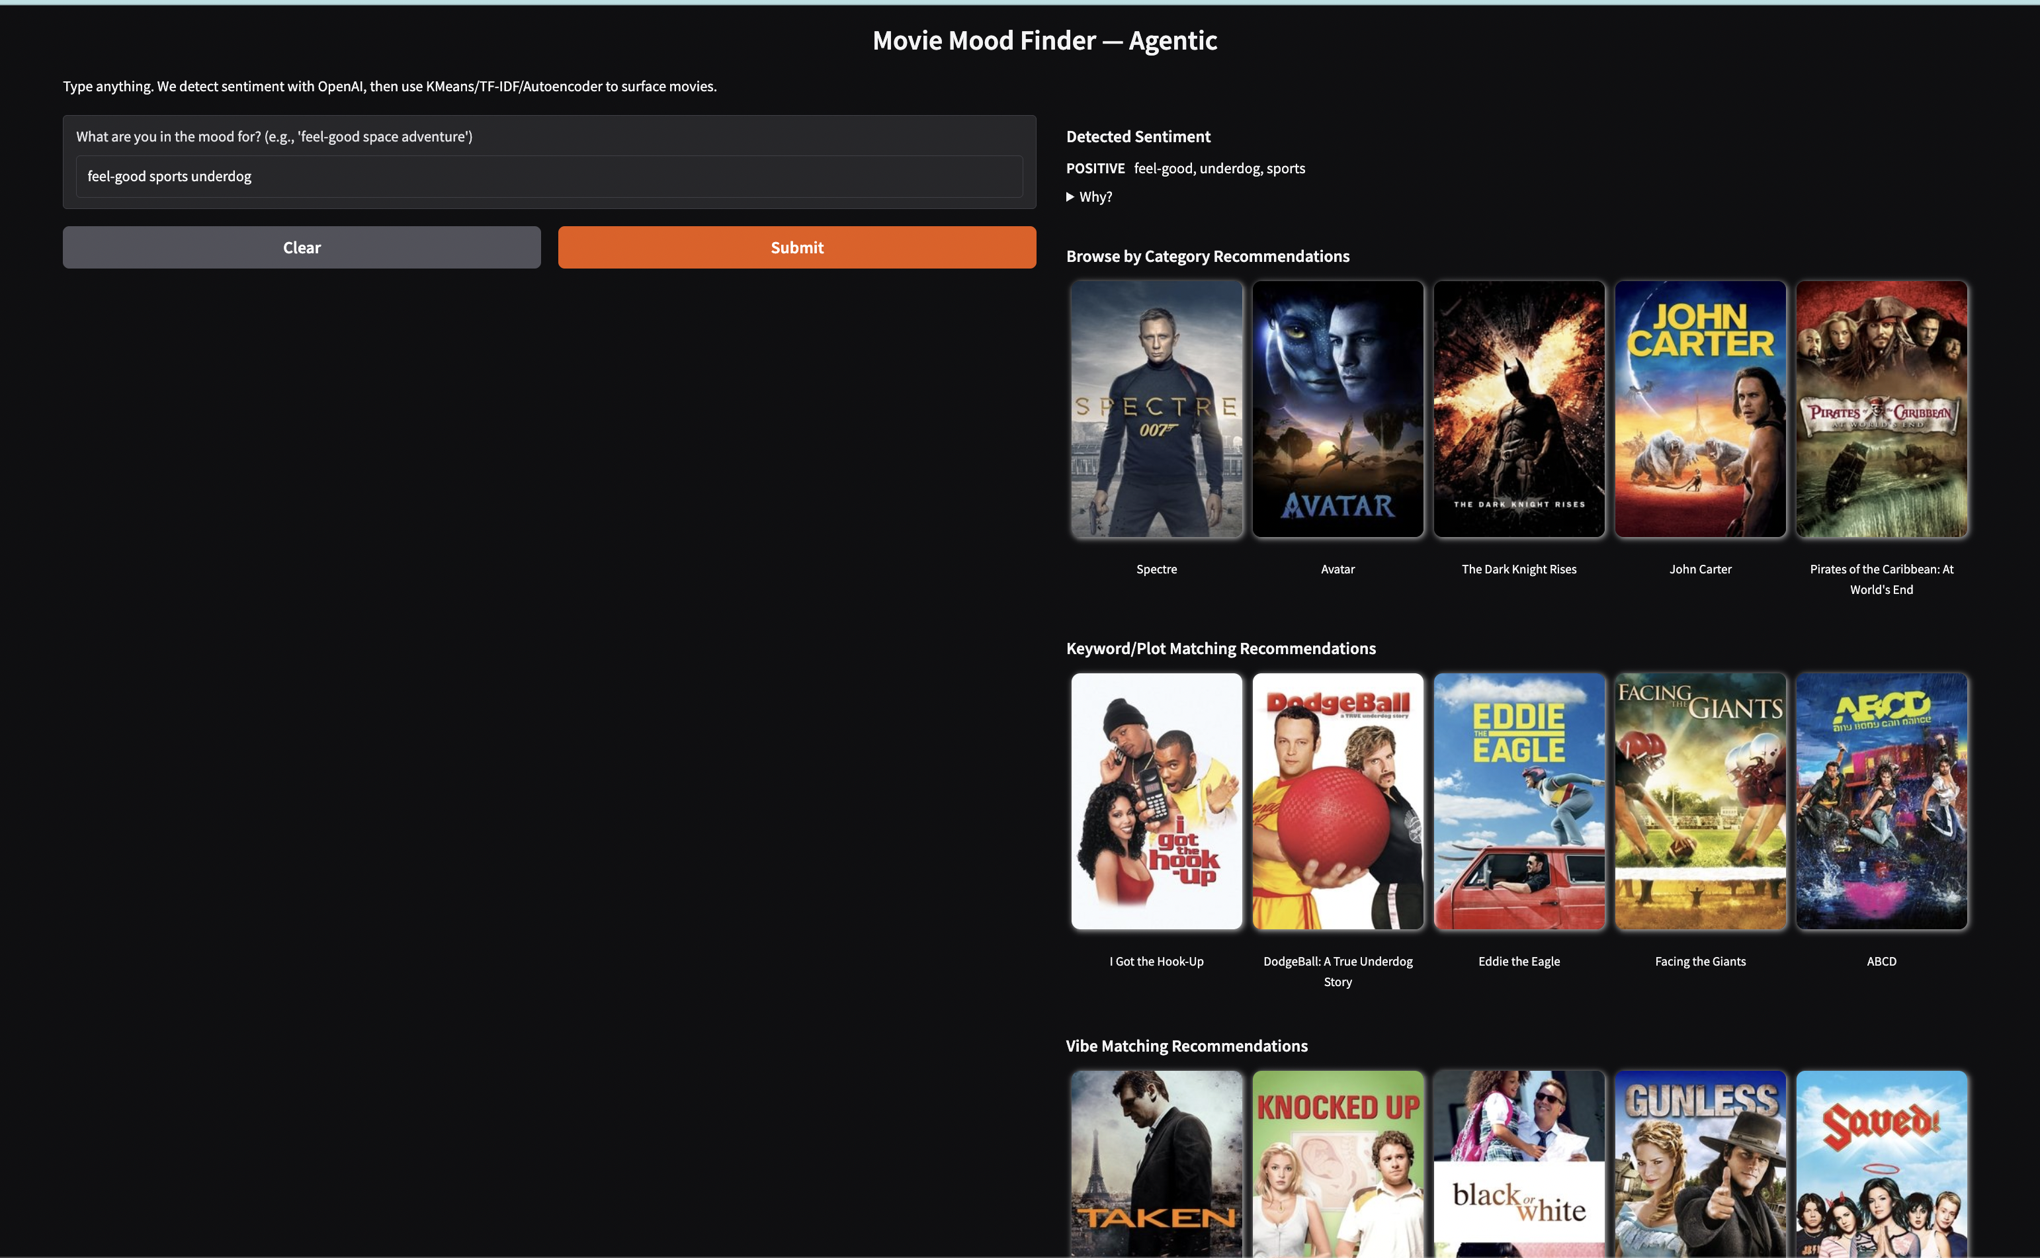

# Conclusion

In conclusion, this project successfully implemented and explored various content-based and hybrid recommendation techniques using movie metadata, providing valuable insights into feature engineering and tuning in a data-constrained environment. While demonstrating the feasibility of providing recommendations based on item attributes, the path to a fully personalized and quantitatively validated recommendation system requires the integration of user interaction data and the development of more advanced modeling and evaluation strategies.

# Reference

Burke, R. (2002). Hybrid recommender systems: Survey and experiments. User Modeling and User-Adapted Interaction, 12(4), 331–370. https://doi.org/10.1023/A:1021240730564

Hinton, G. E., & Salakhutdinov, R. R. (2006). Reducing the dimensionality of data with neural networks. Science, 313(5786), 504–507. https://doi.org/10.1126/science.1127647

Hutto, C. J., & Gilbert, E. (2014). VADER: A parsimonious rule-based model for sentiment analysis of social media text. Proceedings of the International AAAI Conference on Web and Social Media, 8(1), 216–225. https://doi.org/10.1609/icwsm.v8i1.14550

Kaggle. (2019). The movies dataset. <https://www.kaggle.com/rounakbanik/the-movies-dataset>

Pedregosa, F., Varoquaux, G., Gramfort, A., Michel, V., Thirion, B., Grisel, O., Blondel, M., Prettenhofer, P., Weiss, R., Dubourg, V., Vanderplas, J., Passos, A., Cournapeau, D., Brucher, M., Perrot, M., & Duchesnay, E. (2011). Scikit-learn: Machine learning in Python. Journal of Machine Learning Research, 12, 2825–2830.

Reimers, N., & Gurevych, I. (2019). Sentence-BERT: Sentence embeddings using Siamese BERT-networks. Proceedings of the 2019 Conference on Empirical Methods in Natural Language Processing, 3982–3992. https://doi.org/10.48550/arXiv.1908.10084

TensorFlow Team. (2015–present). TensorFlow: Large-scale machine learning on heterogeneous systems. <https://www.tensorflow.org/>

LangChain. (2023–present). LangChain documentation. <https://python.langchain.com/>

MacQueen, J. (1967). Some methods for classification and analysis of multivariate observations. Proceedings of the Fifth Berkeley Symposium on Mathematical Statistics and Probability, 1(14), 281–297. https://projecteuclid.org/euclid.bsmsp/1200512992

Wolf, T., Debut, L., Sanh, V., Chaumond, J., Delangue, C., Moi, A., Cistac, P., Rault, T., Louf, R., Funtowicz, M., Davison, J., Shleifer, S., von Platen, P., Ma, C., Jernite, Y., Plu, J., Xu, C., Le Scao, T., Gugger, S., … Rush, A. M. (2020). Transformers: State-of-the-art natural language processing. Proceedings of the 2020 Conference on Empirical Methods in Natural Language Processing: System Demonstrations, 38–45. https://doi.org/10.48550/arXiv.1910.03771